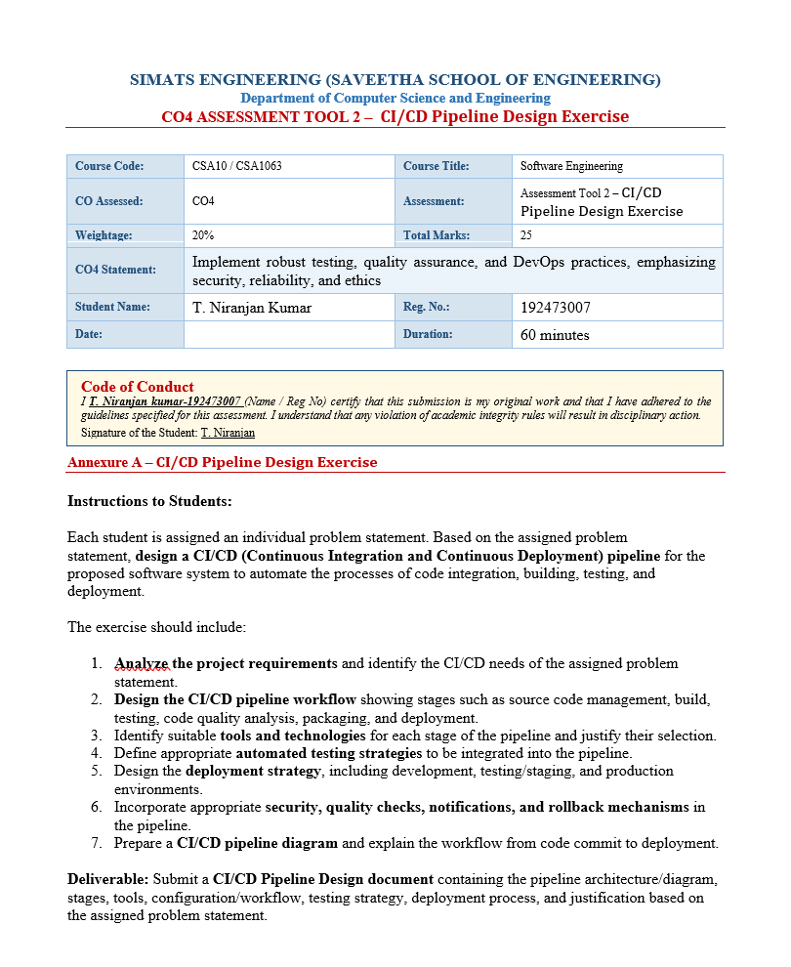
INDEX
S.No | Contents | Page No.
1 | Introduction / Problem Overview | 3
2 | CI/CD Requirements Analysis | 4
3 | CI/CD Pipeline Architecture | 5
4 | Pipeline Stages & Workflow | 6
5 | Tools & Technology Selection | 7
6 | Automated Testing Strategy | 8
7 | Code Quality & Security Checks | 9
8 | Deployment Strategy | 10
9 | Notification & Rollback Strategy | 11
10 | CI/CD Pipeline Diagram & Workflow | 12
11 | Conclusion & Future Scope | 13

1. Introduction / Problem Overview
The Open-Source Contribution Tracker and Recommendation System is designed to help beginner developers enter the open-source ecosystem in a structured manner. The platform recommends suitable beginner-friendly issues according to programming skills and interests, tracks contributions across repositories, monitors pull requests and issue activity, visualizes skill progression, provides community insights, sends personalized notifications, and generates a contribution portfolio.
Because the system depends on frequently changing code, APIs, recommendation logic, user data, and multiple software modules, manual build and deployment processes can introduce delays and errors. A CI/CD pipeline is therefore required to automate software integration, build verification, testing, quality analysis, packaging, and deployment.

1.1 Need for CI/CD
- Frequent code changes from multiple developers need automated integration.
- Recommendation and contribution-tracking features require repeated functional and API testing.
- GitHub API integration can fail or change, so automated tests should detect integration problems early.
- Security and code-quality checks should be performed before deployment.
- Separate environments are required to validate releases safely.
- Fast rollback is required if a production release causes a critical problem.

1.2 CI/CD Goals
- Reduce manual effort in software delivery.
- Detect defects early through automated testing.
- Maintain consistent code quality and security.
- Create repeatable and traceable deployments.
- Improve reliability and release confidence.
- Provide fast feedback to developers.

2. CI/CD Requirements Analysis
The CI/CD design is derived from the proposed system's modules and the assessment requirement to automate code integration, building, testing, quality analysis, packaging, and deployment.
ID | Requirement | CI/CD Support
R1 | Source code and pull-request management | GitHub + branch protection
R2 | Automatic build on code change | GitHub Actions build job
R3 | Automated functional validation | Unit and integration tests
R4 | GitHub API validation | API tests and integration tests
R5 | Code quality assurance | Lint/static analysis
R6 | Security assurance | Dependency and secret scanning
R7 | Deployable application packaging | Docker image/package
R8 | Safe release validation | Staging environment + smoke tests
R9 | Production release control | Quality gate + approval
R10 | Pipeline visibility | Notifications and logs
R11 | Failure recovery | Rollback to previous stable version
R12 | Operational reliability | Production monitoring

2.1 CI/CD Success Criteria
- Every pull request must pass required automated checks before merge.
- Build failures must stop the pipeline.
- Critical test failures must prevent deployment.
- Security vulnerabilities above the accepted threshold must block release.
- Only validated artifacts should reach staging and production.
- Deployment failures should provide actionable notifications.
- A stable previous version should remain available for rollback.

3. CI/CD Pipeline Architecture
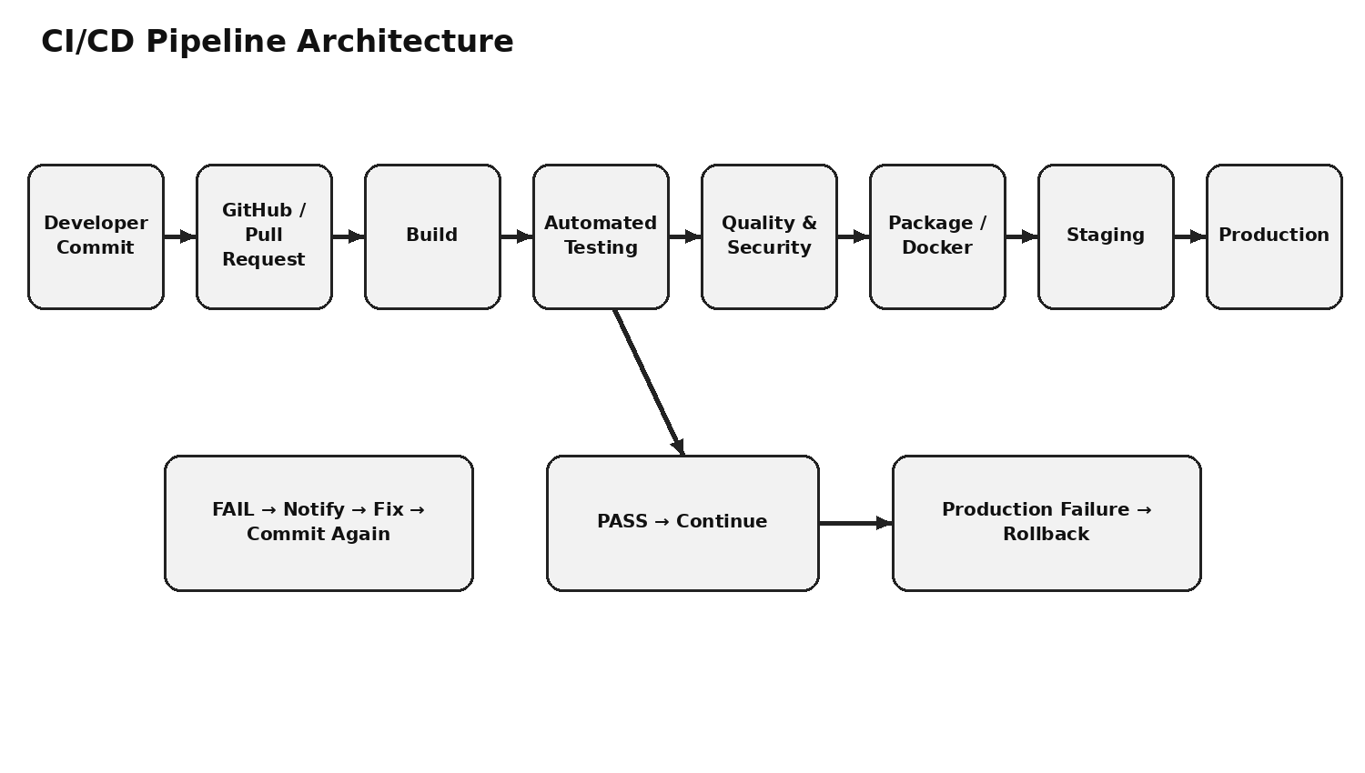
The architecture follows a controlled flow from source code to production. A developer commit or pull request triggers the CI pipeline. The application is built, tested, checked for quality and security, packaged, deployed to staging, validated, and then promoted to production.

3.1 Pipeline Control Points
Control Point | Purpose | Failure Action
Build Gate | Verify successful build and dependency installation | Stop pipeline
Test Gate | Verify functional and integration behavior | Stop pipeline + notify
Quality Gate | Verify code quality and maintainability | Stop pipeline
Security Gate | Detect vulnerable dependencies/secrets | Stop or quarantine release
Staging Gate | Validate deployable release in near-production environment | Do not promote
Production Monitoring | Detect post-deployment problems | Rollback if critical

3.2 Branch Strategy
- Feature branches are used for individual development work.
- Pull requests are used to review and validate changes before merging.
- The main branch contains integration-ready code.
- Production releases are created only from validated changes.
4. Pipeline Stages & Workflow
Stage | Activities | Output
1. Source | Commit, push, pull request, code review | Versioned source code
2. CI Trigger | Workflow starts automatically | Pipeline run
3. Build | Install dependencies, validate project structure | Build artifact
4. Unit Testing | Test individual functions/modules | Test report
5. API/Integration Testing | Validate GitHub API and module interactions | Integration report
6. Quality Analysis | Linting/static analysis | Quality report
7. Security | Dependency and secret scanning | Security report
8. Packaging | Build versioned Docker image/package | Deployable artifact
9. Staging | Deploy and run smoke tests | Validated release
10. Production | Approved deployment and monitoring | Live release

4.1 Pipeline Trigger Conditions
- Push to a feature branch.
- Pull request creation or update.
- Merge to the main branch.
- Manual release trigger for an approved production deployment.

4.2 Quality Gate Logic
If build, mandatory tests, quality checks, or security checks fail, the pipeline stops. The developer receives a notification, fixes the issue, commits the correction, and the pipeline runs again. Only a successful pipeline proceeds to packaging and deployment.

5. Tools & Technology Selection
Tool / Technology | Pipeline Stage | Justification
GitHub | Source control | Provides repository management, version control, pull requests, and collaboration.
GitHub Actions | CI/CD automation | Automates workflows directly within the GitHub repository.
Python / Node.js | Build/runtime | Supports application execution and dependency installation.
PyTest / Jest | Unit testing | Supports repeatable automated tests for application logic.
Postman / API test tools | API testing | Validates API requests, responses, filtering, and integration behavior.
SonarQube / Linter | Quality | Detects code-quality, style, and maintainability issues.
Snyk / Dependency Scanner | Security | Identifies vulnerable third-party dependencies.
Docker | Packaging | Creates a consistent deployable application image.
Staging environment | Pre-production | Allows release validation before production.
Monitoring / Logs | Operations | Provides visibility into production health and failures.

5.1 Why Automation is Important
- Automated checks provide repeatable results.
- Developers receive feedback earlier.
- Manual deployment mistakes are reduced.
- Release evidence can be retained in pipeline logs.
- Standardized steps improve consistency across releases.

6. Automated Testing Strategy
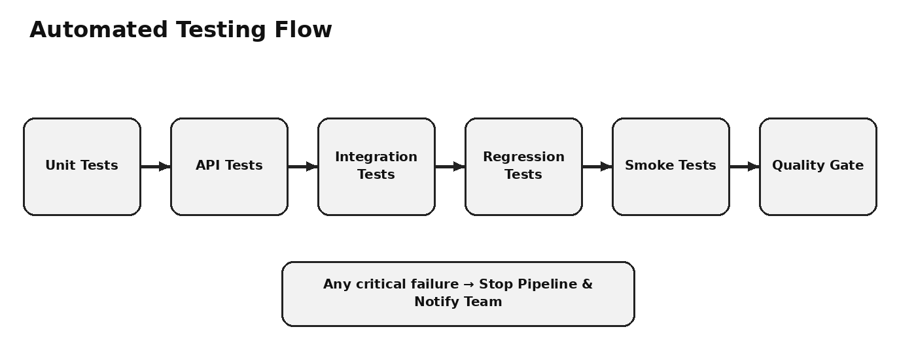
Test Type | Example for Proposed System | Pipeline Point
Unit Testing | Recommendation score, difficulty score, profile validation | After build
API Testing | GitHub issue/repository retrieval and filtering | CI testing
Integration Testing | Profile → recommendation → tracker interactions | CI testing
Regression Testing | Previously working recommendation/tracking functions | CI testing
Smoke Testing | Application startup and key dashboard access | Staging
Security Testing | Dependency and secret validation | Quality/security gate

6.1 Example Automated Test Cases
- Valid programming language should produce an accepted profile value.
- Beginner-friendly labels should return matching issue records.
- GitHub API failure should produce a controlled error.
- Pull request status should be correctly displayed.
- Portfolio generation should include stored contribution data.
- Invalid user input should not crash the application.

6.2 Test Result Handling
The pipeline stores test results as build artifacts or reports. A failed mandatory test causes the workflow to fail, while successful tests allow the next stage to execute.

7. Code Quality & Security Checks
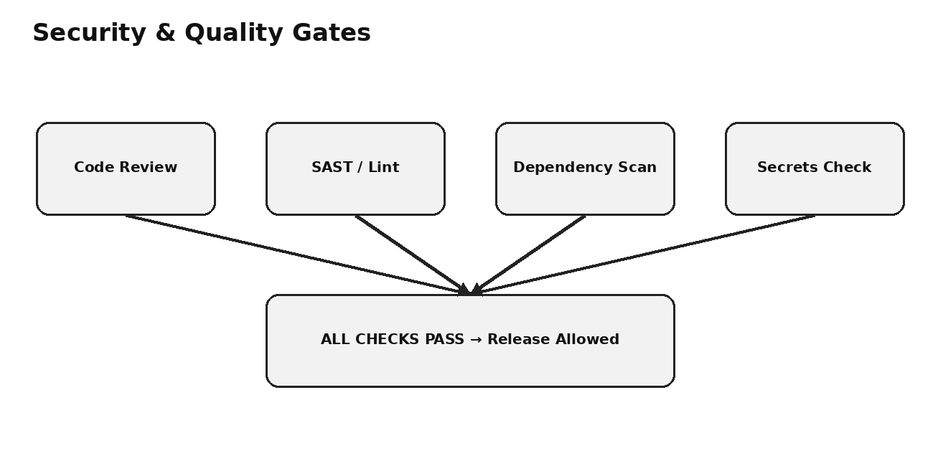

7.1 Code Quality Controls
- Linting and formatting checks.
- Static code analysis.
- Duplicate-code and maintainability checks.
- Required pull-request review.
- Minimum test success requirement before merge.

7.2 Security Controls
- Store API keys and credentials in protected repository secrets.
- Do not hard-code tokens or passwords in source files.
- Scan third-party dependencies for known vulnerabilities.
- Run static security analysis where appropriate.
- Restrict production deployment permissions.
- Keep audit logs of pipeline and deployment activity.

7.3 Ethical and Reliability Considerations
The pipeline should protect developer information and contribution data. Security checks should be applied consistently, and failures should be reported transparently. The deployment process should avoid silently promoting unverified code.

8. Deployment Strategy
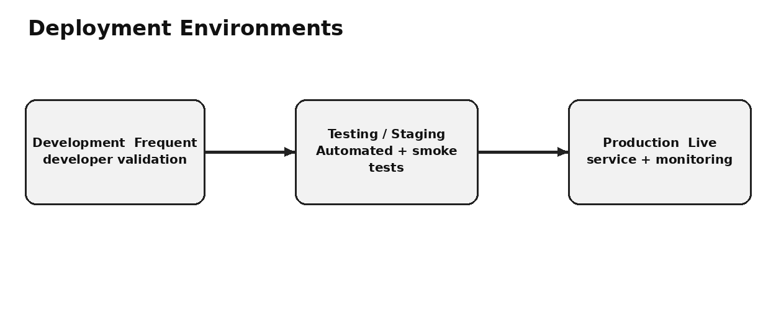
Environment | Purpose | Main Checks
Development | Developer validation and active feature work | Build, unit tests, local integration
Testing / Staging | Production-like release validation | Integration, regression, smoke, security
Production | Live application | Approval, deployment, monitoring

8.1 Deployment Flow
- Build a versioned artifact after successful CI checks.
- Deploy the artifact to staging.
- Run smoke and required regression checks.
- Verify application health and important endpoints.
- Approve the validated release for production.
- Deploy the same validated artifact to production.
- Start or continue production monitoring.

8.2 Deployment Safety
- Use environment-specific configuration.
- Use restricted deployment credentials.
- Keep previous stable artifacts available.
- Do not rebuild an unverified production artifact from scratch.
- Record deployment version and timestamp.

9. Notification & Rollback Strategy

9.1 Notification Strategy
Event | Notification | Action
Build failure | Developer/team alert | Inspect logs and fix code
Test failure | Developer/team alert | Correct failing test or implementation
Security failure | Security/team alert | Resolve vulnerability before release
Staging failure | Release alert | Do not promote to production
Production success | Deployment notification | Continue monitoring
Production failure | Critical alert | Start rollback and investigation

9.2 Rollback Strategy
- Identify the failed production release.
- Stop further rollout if possible.
- Select the last known stable version.
- Redeploy the stable artifact.
- Verify application health using smoke checks.
- Notify the team about rollback completion.
- Investigate the failed release and create a corrective change.
- Run the full CI/CD pipeline again before re-release.

9.3 Monitoring
- Application availability.
- API response failures.
- Error rates and logs.
- Deployment health.
- Critical service failures.

10. CI/CD Pipeline Diagram & Workflow


10.1 End-to-End Workflow
- Developer writes or modifies code.
- Code is committed to the GitHub repository.
- A pull request or configured branch event triggers GitHub Actions.
- The build stage installs dependencies and validates the project.
- Automated unit, API, integration, and regression tests execute.
- Code quality and security gates inspect the release.
- Successful code is packaged into a versioned deployable artifact.
- The artifact is deployed to the staging environment.
- Staging smoke tests verify the release.
- After approval, the validated artifact is deployed to production.
- Monitoring observes the live release.
- If a critical failure occurs, rollback restores the previous stable version.

10.2 Overall Pipeline Benefits
- Faster feedback and delivery.
- Reduced manual errors.
- Consistent testing and quality checks.
- Improved security before release.
- Controlled deployment environments.
- Traceable and repeatable releases.
- Faster recovery through rollback.
11. Conclusion & Future Scope
The proposed CI/CD pipeline provides a structured, automated, and reliable software delivery process for the Open-Source Contribution Tracker and Recommendation System for Beginner Developers. It connects source-code management, continuous integration, automated testing, code-quality analysis, security validation, packaging, staging, production deployment, monitoring, notifications, and rollback into one controlled workflow.
The pipeline reduces dependency on manual build and deployment activities and provides early feedback whenever a change introduces a defect. Automated unit, API, integration, regression, and smoke testing improve confidence in important system functions such as issue recommendation, GitHub integration, contribution tracking, portfolio generation, and dashboard behavior. Quality and security gates ensure that code with critical problems is prevented from progressing to later stages.
The separation of development, testing/staging, and production environments provides additional release control. Staging acts as a production-like validation layer, while production receives only a release that has successfully passed the defined checks. Notifications improve communication by informing developers about failures, successful deployments, and critical production events.
The rollback strategy improves reliability because a previous stable release can be restored when a production deployment causes a critical problem. Security practices such as protected secrets, dependency scanning, static analysis, restricted deployment permissions, and controlled pull-request checks further strengthen the delivery process.

11.1 Future Scope
- Cloud-based deployment and infrastructure automation.
- Container orchestration for scalable production deployment.
- Advanced application and infrastructure monitoring.
- Automated performance and load testing.
- Canary or blue-green deployment strategies.
- More advanced security scanning and policy enforcement.
- Automated release metrics and DevOps dashboards.
- Expansion of the recommendation platform for intermediate and advanced contributors.
Overall, the CI/CD design supports faster, safer, repeatable, and more reliable delivery while preserving quality, security, and operational control. It provides a scalable foundation for the proposed system and can be extended with additional DevOps practices as the platform grows.

